**A**

**PROJECT REPORT**

**ON**

**“All In One Status App”**

Submitted to:

**KURUKSHETRA UNIVERSITY, KURUKSHETRA**

in the partial fulfillment of the requirement for

B.VOC (SOFTWARE DEVELOPMENT) SEM- 2nd

**Session 2018-19**



Under Supervision of Submitted By:

Mrs. **Nidhi Sharma** **Manpreet Singh**

(Assistant Professor)

B.VOC (Software Development) SEM-2nd

Dept. of Computer Sci. & App. College Roll. 2379410040

**Uni. Roll No. 180123513**

**S.D COLLEGE (LAHORE) AMBALA CANTT**

**INDEX**

* **CERTIFICATE**
* **ACKNOWLEDGMENT**
* **INTRODUCTION**
* **SOFTWARE & HARDWARE REQUIREMENTS**
* **INTRODUCTION TO LANGUAGE**
* **CODING**
* **SCREENSHOTS**
* **CONCLUSION & FUTURE SCOPE**

**Certificate - 1**

It is to validate that **Manpreet Singh** s/o Mr. Dalwinder Singh of class B. Voc. (Software Development) – 1st Yr. under university roll number: 180123513 and college roll number: 2379410040 has completed the project titled “**Yoga Anonymous”** in which the languages used are HTML, CSS JavaScript and PHP for the degree of Bachelors of Vocational Studies (Software Development)-Semester-II under my supervision. The work done in project is a result of the candidate’s own efforts and report maintain is satisfied as per requirement.

I wish him good success in his future.

Mrs. Nidhi Sharma Manpreet Singh

Project Guide

Dept. of Computer Sc. & App.

**Certificate - 2**

It is to validate that **Manpreet Singh** s/o Mr. Dalwinder Singh of class B. Voc. (Software Development) – 1st Yr. under university roll number: 180123513 and college roll number: 2379410040 has completed the project titled **“Yoga Anonymous”** in which languages used are HTML, CSS, JavaScript and PHP for the degree of Bachelors of Vocational Studies (Software Development)-Semester-II under my supervision. The work done in project is a result of the candidate’s own efforts and report maintain is satisfied as per requirement.

We wish him good success in his future.

Dr Girdhar Gopal Dr Rajinder Singh

H.O.D. Principal

Dept. of Computer Sc. & App.

Sanatan Dharma College Ambala Cantt

**Acknowledgement**

The success and final outcome of this project required a lot of guidance and assistance from many people and I am extremely privileged to have got this all along the completion of my project. All that I have done is only due to such supervision and assistance and I would not forget to thank them.

I respect and thank to Dr Rajinder Singh for providing me an opportunity to do the project work in college and giving us all support and guidance which made me complete the project duly. I am extremely thankful to facility for providing such a nice support and guidance, although he had busy schedule managing the corporate affairs.

I owe my deep gratitude to our project guide Ms. Nidhi who took keen interest on our project work and guided us all along, till the completion of our project work by providing all the necessary information for developing a good system.

I am thankful to and fortunate enough to get constant encouragement, support and guidance from all teaching staff of computer department which helped us in successfully completing our project work.

**Introduction:-**

**Yoga** is essentially a spiritual discipline based on an extremely subtle science, which focuses on bringing harmony between mind and body. It is an art and science of healthy living. The word '**Yoga**' is derived from the Sanskrit root 'Yuj', meaning 'to join' or 'to yoke' or 'to unite'.

My website has the following basic pages  
  
1. Lotus Position

2. Hand Stand

3. Vrikasan

4. Salabhasana

5. Chakrasan

**Hardware Requirements:-**

* Pentium- IV (Processor).
* 256 MB Ram
* 512 KB Cache Memory
* Hard disk 10 GB
* Microsoft Compatible 101 or more Key Board

**Software Requirements: -**

* Operating System : Windows
* Web-Technology: PHP
* Front-End: HTML,CSS,JAVASCRIPT
* Back-End: MySQL
* Web Server:Apache SERVER.

**Introduction to Language**

## HTML | Introduction

**HTML** stands for Hyper Text Markup Language. It is used to design web pages using markup language. HTML is the combination of Hypertext and Markup language. Hypertext defines the link between the web pages. Markup language is used to define the text document within tag which defines the structure of web pages. This language is used to annotate (make notes for the computer) text so that a machine can understand it and manipulate text accordingly. Most of markup (e.g. HTML) languages are human readable. Language uses tags to define what manipulation has to be done on the text.  
HTML is a markup language which is used by the browser to manipulate text, images and other content to display it in required format. HTML was created by Tim Berners-Lee in 1991. The first ever version of HTML was HTML 1.0 but the first standard version was HTML 2.0 which was published in 1999.

| **HTML VERSION** | **YEAR** |
| --- | --- |
| HTML 1.0 | 1991 |
| HTML 2.0 | 1995 |
| HTML 3.2 | 1997 |
| HTML 4.01 | 1999 |
| XHTML | 2000 |
| HTML 5 | 2014 |

Structure of HTML

<HTML>

<HEAD>

<!--This section contain title and supplementary information about the page-->

</HEAD>

<BODY>

<-- This section contains the document content-->

</BODY>

</HTML>

**PHP | Introduction**

The term PHP is an acronym for PHP: Hypertext Preprocessor. PHP is a server-side scripting language designed specifically for web development.

**Basic PHP Syntax**

A PHP script can be placed anywhere in the document.

A PHP script starts with **<?php** and ends with **?>**:

<?php

//php code goes her

?>

**Including CSS in HTML Document**

1. Inline style sheet.
2. Internal style sheet.
3. External style sheet.
4. Imported style sheet.

**Design Language CSS**

* **CSS** stands for **C**ascading **S**tyle **S**heets
* CSS describes how HTML elements are to be displayed on screen, paper, or in other media
* CSS saves a lot of work. It can control the layout of multiple web pages all at once
* External stylesheets are stored in CSS files

## CSS Syntax

## A CSS rule-set consists of a selector and a declaration block:

## CSS selector

## The selector points to the HTML element you want to style.

## The declaration block contains one or more declarations separated by semicolons.

## Each declaration includes a CSS property name and a value, separated by a colon.

## A CSS declaration always ends with a semicolon, and declaration blocks are surrounded by curly braces.

**JAVASCRIPT:-**

**JavaScript** is an [object-oriented](http://en.wikipedia.org/wiki/Object-oriented) [scripting language](http://en.wikipedia.org/wiki/Scripting_language) used to enable [programmatic](http://en.wikipedia.org/wiki/Computer_programming) access to objects within both the [client application](http://en.wikipedia.org/wiki/Client_(computing)) and other [applications](http://en.wikipedia.org/wiki/Application_software). It is primarily used in the form of [client-side JavaScript](http://en.wikipedia.org/wiki/Client-side_JavaScript), implemented as an integrated component of the [web browser](http://en.wikipedia.org/wiki/Web_browser), allowing the development of enhanced [user interfaces](http://en.wikipedia.org/wiki/User_interface) and dynamic [websites](http://en.wikipedia.org/wiki/Website). JavaScript is a [dialect](http://en.wikipedia.org/wiki/Programming_language_dialect) of the [ECMAScript](http://en.wikipedia.org/wiki/ECMAScript) standard and is characterized as a [dynamic](http://en.wikipedia.org/wiki/Dynamic_language), [weakly typed](http://en.wikipedia.org/wiki/Weak_typing), [prototype-based](http://en.wikipedia.org/wiki/Prototype-based_programming) language with [first-class functions](http://en.wikipedia.org/wiki/First-class_function). JavaScript was influenced by many languages and was designed to look like [Java](http://en.wikipedia.org/wiki/Java_(programming_language)), but to be easier for non-programmers to work with.

**MySQL:-**

## MySQL Introduction

There are a large number of database management systems currently available, some commercial and some free.  
Some of them: Oracle, Microsoft Access, Mysql and PostgreSQL.  
These database systems are powerful, feature-rich software, capable of organizing and searching millions of records at very high speeds.

### Understanding Databases, Records, and Primary Keys

Every Database is composed of one or more tables.  
These Tables, which structure data into rows and columns, impose organization on the data.

The records in a table (below) are not arranged in any particular order.  
To make it easy to identify a specific record, therefore, it becomes necessary

### Standing Relationships and Foreign Keys (RDBMS)

You already know that a single database can hold multiple tables.  
In a Relational database management system (RDBMS), these tables can be linked to each other by one or more common fields, called **foreign keys**.

### What is Database administrator (DBA) ?

Database administrator is the super user of database, he has unrestricted rights and privileges to access database, grant permission to other database users.

### What is Database use (DBU)?

Database user is the person who uses the database in a restricted privileges, provided by database administrator.

### Download MySQL Database

If you have installed PHP’s WAMP or XAMPP server, then mysql database already exists. If you don’t have then download mysql database from herehttp://www.mysql.com

**Coding**

Front page:-

<html>

<head>

<style>

*{

margin:0px;

padding:0px;

}

.container

{

width:100%;

min-height:100px;

}

.header{

height:100px;

background-color:skyblue;

font-style:Calligraphic;

font-size:200%;

text-align:center;

}

ul{

text-align:center;

font-size:200%;

font-style:cooper black;

padding:0px;

margin:0px;

}

a{

text-decoration:none;

}

li{

display:block;

width:150px;

float:left;

}

.catdiv{

height:240px;

background-color:orange;

}

.itemdiv{

height:150px;

width:250px;

float:left;

margin:20px;

}

p{

font-weight:bold;

font-size:20px;

margin:13px;

padding:10px;

}

.imgclass{

height:150px;

width:150px;

padding:10px;

border-radius:15%;

box-shadow: 5px 10px;

}

#unamediv{

position:absolute;

left:1200px;

top:105px;

font-family:cursive;

}

</style>

</head>

<body>

<div class="container">

<div class="header">

<h1><img src="logo3.jpg" height=100px; width=100px; align="left">Yoga Anonymous</h1>

</div>

<div id='unamediv'>

<h3 style="font-size: 30px;">

<?php

session_start();

if(isset($_SESSION['id']))

{

echo "Welcome ".$_SESSION['username'];

}

?>

</h3>

</div>

<?php

include "hedder.php";

?>

</div>

<div class="pic">

<img src="vriksasan.jpg" height=600px; width=1520px;>

<div class="catdiv">

<?php

$con=mysqli_connect("localhost","root","");

mysqli_select_db($con,"mannat");

$query="select * from yoga";

$catrows=mysqli_query($con,$query);

if(mysqli_num_rows($catrows)>0)

{

while($row=mysqli_fetch_assoc($catrows))

{

echo "<div class='itemdiv'>";

echo "<a href='pose.php?yogaid=".$row['yogaid']."'><img src='".$row['picname']."' class='imgclass'></a>";

echo "<a href='pose.php?yogaid=".$row['yogaid']."'><p>&nbsp;&nbsp;".$row['yoga asan']."</p></a>";

echo "</div>";

}

}

?>

</div>

</div>

</body>

</html>

Hedder :-

<html>

<head>

<style>

*{

margin:0px;

padding:0px;

}

a{text-decoration: none;}

.navbar{

list-style-type: none;

overflow:hidden;

font-size:30px;

font-style:italic;

background-color:lightgrey;

}

.navbar > li

{

float: left;

margin: 4px 4px;

padding: 8px 8px;

}

.navbar > li a:hover

{

background-color:lightblue;

border-radius:10px;

}

</style>

</head>

<ol class=navbar>

<li><a href="front2.php">Home</a></li>

<li><a href="login.php">Login</a></li>

<li><a href="register.php">Register</a></li>

<li><a href="History.php">History</a></li>

<li><a href="chakras.php">Chakras</a></li>

<li><a href="logout.php">Logout</a></li>

<li><a href="about.php">About</a></li>

</ol>

Login:-

<html>

<head>

<style>

*{

margin:0px;

padding:0px;

}

.container {

position: relative;

text-align: center;

color: white;

}

.centered {

position: absolute;

top: 50%;

left: 50%;

transform: translate(-50%, -50%);

}

</style>

</head>

<body>

<div class="container">

<?php

include "hedder.php";

?>

<img src="bg1.jpg" height=695px; width=1540px;>

<div class="centered">

<form action="http://localhost/mannat/yoga/loginlogic.php" method="post">

Email id:

<input type="text" name="ename" placeholder="Enter Your Email id"><br><br>

Password:

<input type="password" name="pass" placeholder="Enter Your password"><br><br>

<input type="submit" name="login" value="login">

<input type="reset" name="reset"><br><br>

</form>

</div>

</body>

</html>

History:-

<html>

<style>

.history{

font:italic 25px Lucida Sans;

}

</style>

<head>

</head>

<body bgcolor="orange">

<div class="history">

<?php

include "hedder.php";

?>

<p>

<h1 align="center">History of yoga</h1>

<br>

Yoga’s history has many places of obscurity and uncertainty due to its oral transmission of sacred texts and

the secretive nature of its teachings. The early writings on yoga were transcribed on fragile palm leaves that

were easily damaged, destroyed or lost. The development of yoga can be traced back to over 5,000 years ago, but

some researchers think that yoga may be up to 10,000 years old old. Yoga’s long rich history can be divided into

four main periods of innovation, practice and development.<br>

<br>

<h2>Pre-Classical Yoga</h2>

<br>

The beginnings of Yoga were developed by the Indus-Sarasvati civilization in Northern India over 5,000

years ago. The word yoga was first mentioned in the oldest sacred texts, the Rig Veda. The Vedas were

a collection of texts containing songs, mantras and rituals to be used by Brahmans, the Vedic priests.

Yoga was slowly refined and developed by the Brahmans and Rishis (mystic seers) who documented their practices

and beliefs in the Upanishads, a huge work containing over 200 scriptures. The most renowned of the Yogic

scriptures is the Bhagavad-Gîtâ, composed around 500 B.C.E. The Upanishads took the idea of ritual sacrifice

from the Vedas and internalized it, teaching the sacrifice of the ego through self-knowledge, action

(karma yoga) and wisdom (jnana yoga).<br>

<br>

<h2>Classical Yoga</h2>

<br>

In the pre-classical stage, yoga was a mishmash of various ideas, beliefs and techniques that often conflicted

and contradicted each other. The Classical period is defined by Patanjali’s Yoga-Sûtras, the first systematic

presentation of yoga. Written some time in the second century, this text describes the path of Raja Yoga, often

called "classical yoga". Patanjali organized the practice of yoga into an "eight limbed path" containing the

steps and stages towards obtaining Samadhi or enlightenment. Patanjali is often considered the father of yoga

and his Yoga-Sûtras still strongly influence most styles of modern yoga.<br>

<br>

<h2>Post-Classical Yoga</h2>

<br>

A few centuries after Patanjali, yoga masters created a system of practices designed to rejuvenate the body and

prolong life. They rejected the teachings of the ancient Vedas and embraced the physical body as the means to

achieve enlightenment. They developed Tantra Yoga, with radical techniques to cleanse the body and mind to

break the knots that bind us to our physical existence. This exploration of these physical-spiritual

connections and body centered practices led to the creation of what we primarily think of yoga in the West:

Hatha Yoga.<br>

<br>

<h2>Modern Period</h2>

<br>

In the late 1800s and early 1900s, yoga masters began to travel to the West, attracting attention

and followers. This began at the 1893 Parliament of Religions in Chicago, when Swami Vivekananda.

In the 1920s and 30s, Hatha Yoga was strongly promoted in India with the work of T. Krishnamacharya,

Swami Sivananda and other yogis practicing Hatha Yoga. Krishnamacharya opened the first Hatha

Yoga school in Mysore in 1924 and in 1936 Sivananda founded the Divine Life Society on the banks

of the holy Ganges River. Krishnamacharya produced three students that would continue his legacy

and increase the popularity of Hatha Yoga: B.K.S. Iyengar, T.K.V. Desikachar and Pattabhi Jois.

Sivananda was a prolific author, writing over 200 books on yoga, and established nine ashrams and

numerous yoga centers located around the world.

The importation of yoga to the West still continued at a trickle until Indra Devi opened her

yoga studio in Hollywood in 1947. Since then, many more western and Indian teachers have become

pioneers, popularizing hatha yoga and gaining millions of followers. Hatha Yoga now has many

different schools or styles, all emphasizing the many different aspects of the practice.<br>

<br>

</p>

</div>

</body>

</html>

Chakras:-

<html>

<head>

<title> seven chakras</title>

<style>

#menu>li:hover .submenu

{

display:block;

}

.h1{

margin-top:7px;

color:blue;

text-decoration:none;

text-align:center;

height:18%;

width:100%;

font:bold italic 80px Rock Well Extra Bold,serif;

text-transform:capitalize;

}

.topleft{

position:absolute;

top:75px;

left:16px;

width:190px;

height:160px;

z-index:1;

}

#p{

margin-top:20px;

color:red;

text-decoration:none;

text-align:left;

left:20px;

height:5%;

width:100%;

font:bold italic 500% Rock Well Extra Bold,serif;

text-transform:capitalize;

}

p.one{

text-transform:capitalize;

font:italic 25px Lucida Sans;

color:black;

}

h1.one{

font-size:45px;

}

body{

background-color:lightgreen;

}

.v{

margin-left:5%}

<a href="#one">Muladhara (Root Chakra)</a>

<a href="#two">Svadhisthana (Sacral or Pelvic Chakra)</</a>

<a href="#three">Manipura (Navel Chakra)</a>

<a href="#four">Anahata (Heart Chakra)</a>

<a href="#five">Vishuddha (Throat Chakra)</a>

<a href="#six">Anja (Third-Eye Chakra</a>

<a href="#seven">Sahasrara (Crown Chakra)</a>

</style>

</head>

<body>

<div style="background:linear-gradient(red,grey); height:51px; width:100%;">

<?php

include "hedder.php";

?>

</div>

<a name="top"><div class="h1" style="background:radial-gradient(red,yellow); height:120px; width:100%;"> 7 Chakras

</div></a>

<div class="topleft"><img src="chakr1.jpg" height="100" width="190" style="border-radius:50%; border=1px solid gray;"></img>

</div>

<img src="chkrr.jpg" height="520" width="100%"></img>

<p id="p">A Beginner’s Guide to the Chakras</p><br><br><br>

<a href="#one">Muladhara (Root Chakra)</a><br>

<a href="#two">Svadhisthana (Sacral or Pelvic Chakra)</</a><br>

<a href="#three">Manipura (Navel Chakra)</a><br>

<a href="#four">Anahata (Heart Chakra)</a><br>

<a href="#five">Vishuddha (Throat Chakra)</a><br>

<a href="#six">Anja (Third-Eye Chakra</a><br>

<a href="#seven">Sahasrara (Crown Chakra)</a><br><br>

<p class="one">Start by thinking of chakras as a blueprint for your own self-care, and your yoga practice as the architect that makes that blueprint a reality.

The most direct way to use the chakras is to learn how each one is associated with an element in nature.

As Alan Finger, founder of ISHTA Yoga, explains, the first five chakras are associated with the physical elements earth, water, fire, air, and ether (or space).

The last two chakras are thought to connect us beyond the earthly realm, so they are associated with the elements of light and cosmic energy.</p>

<p class="one">Once you learn the element that each chakra is associated with, you can start to suss out how that element feels in your body.

And thinking about your body in these symbolic terms can help you access new stores of energy with the practices detailed in these pages.

For example, the root chakra is associated with earth. When it’s in balance, we feel strong and grounded; when it’s out of balance, we may feel unrooted and insecure.

Or take the pelvic chakra, which is associated with water. When it’s in balance, we feel fluid and like our creative juices are flowing.

When it’s not, we might feel rigid, dry, or emotionally brittle, like a plant that hasn’t been watered enough.</p>

<p class="one"> In order to restore balance in your chakras, you must first tune in to how you’re feeling, then figure out which chakra to stimulate to counteract the imbalance.

For example, if you’re feeling low in energy, you can do poses that target the navel chakra to rekindle your inner fire.

If you’re feeling anxious and long to feel more grounded, choose poses for the earthy root chakra.

Or if you seek more courage to speak your truth, the right poses can open and stimulate the throat chakra.</p>

<p class="one">The effects of a chakra-based practice can have a tangible, empowering ripple effect on your life.

Jasmine Tarkeshi, vinyasa teacher and cofounder of Laughing Lotus Yoga Center, says she’s been

doing more root-chakra practices since becoming a new mom, and the effect is palpable.

“If I’m feeling frenzied, I hold the poses longer to feel more grounded and present,” she says.

“It informs the rest of my day to the point where maybe I’m not losing my keys so much or I’m not so busy or forgetful that I skip lunch.

If I specifically use the poses medicinally rather than just haphazardly, I can really change my day.” </p>

<br><br><br>

<h3 style="font-size:40px">7 Chakras Healing</h3>

<iframe class="v" width="854" height="480" src="https://www.youtube.com/embed/-XEAGZbKAsk" frameborder="0" allowfullscreen></iframe>

<br><br><br>

<h1 class="one"><a name="one">1.Muladhara (Root Chakra)</a></h1>

<h3>Element: Earth</h3>

<h3>Color: Red</h3>

<h3>Sound: Lam</h3>

<p class="one">The Muladhara governs your family ties and feelings of survival, belonging, and guardedness.

Your earliest memories are stored here, including whether or not your basic needs were met. When it is blocked or

out of balance, you can become needy, have low self-esteem, or have self-destructive behaviors.

When Muladhara is in balance, you feel strong and confident; you can stand up on your own two feet and take care of yourself.</p>

<img src="c1.jpg" width="25%"></img>

<h1 style="color:blue">Vrksasana (Tree Pose)</h1>

<p class="one">Stand with your feet hip-width apart, creating a stable base.

On an exhale, soften your knees, and release your tailbone as you engage your thighs.

Draw the sole of your right foot to the inside of your left inner thigh or calf; continue

dropping your tailbone and engaging the standing leg’s thigh to keep the stable alignment you had standing on both feet.

Press through your left foot as you lift through the crown of your head. Hold for 5 breaths, and switch sides.

Allow gravity to root you down, while noticing how prana moves up your spine.</p>

<h1 class="one"><a name="two">2.Svadhisthana (Sacral or Pelvic Chakra)</a></h1>

<h3>Element: Water</h3>

<h3>Color: Orange</h3>

<h3>Sound: Yam</h3>

<p class="one">This chakra corresponds with your reproductive and sexual organs, and represents fluidity, creativity, and fertility.

You can take a literal interpretation of this, or associate this chakra with whether or not you feel deserving of a pleasurable, abundant, creative life.

When it’s out of balance, you can feel emotionally unstable, guilty, or hard on yourself.

When Svadhisthana in balance, you feel creative, positive, and receptive to change—like the ocean and its tides, you’re in the flow.</p>

<img src="c2.jpg" width="25%"></img>

<h1 style="color:blue"> Deviasana (Goddess Pose)</h1>

<p class="one">Step your feet wide, turn your toes out, and sink your hips far enough to bring each knee over its corresponding ankle.

Place your hands on your thighs and draw your tailbone down as the pubis lifts.

Breathe deeply and move side to side, rocking your pelvis back and forth. You can fold down and move your arms side to side between your feet.

The point is to enjoy the movement. Feel free to sigh or make sounds. Hold for 8-10 breaths.

By opening the hips, you draw focus to the reproductive organs; in swaying, you recognize life’s ebb and flow.</p>

<h1 class="one"><a name="three">3.Manipura (Navel Chakra)</a></h1>

<h3>Element: Fire</h3>

<h3>Color: Yellow</h3>

<h3>Sound: Ram</h3>

<p class="one">You’ve heard the expression “firing on all cylinders.” When the Manipura is in balance, you feel

alive and have the self-esteem and confidence to take action and be productive. When it’s blocked, you lack courage, have low self-esteem,

and feel stagnant and inert. By working on this chakra, you can awaken your true personal inner power and work through your fear of taking risks.</p>

<img src="c3.jpg" width="25%"></img>

<h1 style="color:blue"> Navasana (Boat Pose)</h1>

<p class="one"> Begin seated with your legs ahead of you. Hug your knees into your chest, and then grab behind your knees

to help lift your feet off the floor and balance on your sitting bones. Lift your chest, and draw your shoulders down.

Shift your weight forward to the front of your sitting bones as you draw in your navel, engaging your abdominals,

and extend your arms forward and your legs up into Navasana. As you exhale, cross your arms at your chest,

and lower your legs until they’re a few inches off the ground;

inhale to rise back to Navasana. Repeat 5 times, and then lower to your back.

Boat is an energizing pose that ignites your core muscles, creating power for transformation.</p>

<h1 class="one"><a name="four">4.Anahata (Heart Chakra)</a></h1>

<h3>Element: Air</h3>

<h3>Color: Green</h3>

<h3>Sound: Yam</h3>

<p class="one">Awaken to the power of unconditional love within you through compassion, forgiveness, and acceptance.

When the heart chakra is blocked, you become possessive and codependent, and may form dysfunctional relationships. You may also stay isolated for fear of rejection.

When you stimulate the Anahata chakra, you can heal past wounds by reopening your heart, learn to love unconditionally, and form healthy relationships.</p>

<img src="c4.jpg" width="25%"></img>

<h1 style="color:blue"> Ustrasana (Camel Pose)</h1>

<p class="one">Come to your knees, and sit back on your heels. Join your hands at your heart center. Tuck your toes and rise

to bring your hips over your knees, making sure knees and toes are hip-width apart. Place your palms on your lower back with the fingers

pointing up and gently draw your sacrum down, as your front hip bones lift. Keep your chin in toward your chest, and lean back.

Hug the shoulder blades toward each other. Stay here and breathe, or reach for your heels with your hands. The head is the last thing to

release, if it’s comfortable. After a few breaths, bring your hands back to your sacrum and sit on your heels,

returning your hands to prayer and bowing your head. Camel opens the heart center. Before you arch back, consider

dedicating the posture to someone for whom you feel compassion.</p>

<h1 class="one"><a name="five">5.Vishuddha (Throat Chakra)</a></h1>

<h3>Element: Ether</h3>

<h3>Color: Blue</h3>

<h3>Sound: Ham</h3>

<p class="one">When Vishuddha is blocked, you may feel like you can’t find your voice or your truth. You may also be overly talkative and not listen to others.

When this chakra is open and stimulated, your voice moves through space to help you communicate your emotions in healthy ways. You also become

better at listening to others and honoring their personal truths without judgment.</p>

<img src="c5.jpg" width="25%"></img>

<h1 style="color:blue"> Salamba Sarvangasana (Supported Shoulderstand)</h1>

<p class="one"> Lie down with your shoulders supported on a folded blanket, head on the floor. Bend your knees, rock your hips up, lift your legs

overhead, and then release your toes toward the floor beyond the crown of your head. Place your hands midback, and lift one leg at

a time skyward. Allow your gaze to drop toward your heart, and hear the sound of your breath. Feel free to express yourself by joining the

soles of the feet, or by lowering one leg at a time toward the floor. Hold for up to 2 minutes. To release, lower both feet to the floor

above your head, release your hands to the floor, and lower yourself vertebra by vertebra. Freeing the neck and spine, and

then turning the senses in toward your breath, allows you to connect with your own rhythm.</p>

<h1 class="one"><a name="six">6.Anja (Third-Eye Chakra)</a><h1>

<h3>Element: Light</h3>

<h3>Color: Indigo</h3>

<h3>Sound: OM</h3>

<p class="one">This chakra is associated with your intuition, or sixth sense, and governs how the rest of the chakras function.

When Ajna is functioning well, you have insight, and you trust your inner wisdom to face life’s challenges and choices. When it’s blocked,

you feel close-minded, too attached to logic, untrusting, and cynical. Working on the sixth chakra opens your mind to the bigger picture

and different perspectives, and it helps you receive the wisdom that cannot be seen or heard by ordinary senses.</p>

<img src="c6.jpg" width="25%"></img>

<h1 style="color:blue"> Sukhasana (Easy Pose)</h1>

<p class="one">Come to a seat. Fold one heel in toward your groin, and then the other. If your knees aren’t lower than your hips,

sit on a folded blanket. Cup your palms toward each other, touching opposite fingertips in Hakini Mudra. For 10 breaths, close your eyes,

pose a question to yourself, and focus on the sound of your breath, placing the tip of your tongue to the roof of your mouth as you inhale,

and relaxing it as you exhale. Release the backs of your hands to your knees, and see if you sense an answer. Stay here for up to 5 minutes.

Hakini Mudra is known to increase the power of concentration, and in this pose you can easily access calm focus.</p>

<h1 class="one"><a name="seven">7.Sahasrara (Crown Chakra)</a><h1>

<h3>Element: Cosmic Energy</h3>

<h3>Color: Violet or White</h3>

<h3>Sound: OM</h3>

<p class="one"> The crown chakra connects to beauty itself and the spiritual realm. It helps you to understand who you are beyond your physical

self—that you are a spiritual being having a human experience. It is not located in the body but actually hovers above the crown of the head.

When it’s closed, you think happiness can only come from the outside, and you suffer. Working on this chakra helps you to feel free in any situation.</p>

<img src="c7.jpg" width="25%"></img>

<h1 style="color:blue"> Savasana (Corpse Pose)</h1>

<p class="one"> Make sure you’re warm and comfortable, and lie down on your back. You can cover yourself with a blanket, cover your eyes with an

eye pillow, or place a rolled-up blanket under your knees or head. Open your legs hip-width apart, and release your arms to your sides with your

palms facing up. Take a deep breath and squeeze every part of your body tight, lifting your head, arms, and legs off the floor. Hold for a moment,

and let everything go with a big exhale out of the mouth. Do this several times. Imagine a lotus flower at the crown of your head. With every inhale,

imagine Divine light pouring in through the flower, and with every exhale, let go of anything that binds you to the past. Stay for 5–20 minutes, then

slowly bring your awareness back to your breath, and move your fingers and toes to reconnect to your physical body without losing your connection to your infinite self.</p>

<a href="#top"><img src="t.jpg" style="border-radius:75%; border=1px solid gray;"></a><div class="h1" style="background:radial-gradient(red,grey); height:30px; width:100%;">

</body>

</html>

About:-

<html>

<style>

*{

margin:0px;

padding:0px;

}

.container {

position: relative;

text-align: center;

color:lightred;

}

.centered {

position: absolute;

top: 50%;

left: 50%;

transform: translate(-50%, -50%);

}

.about{

font:italic 25px Lucida Sans;

}

</style>

<head>

</head>

<body bgcolor="teal">

<div class="container">

<div class="about">

<?php

include "hedder.php";

?>

<img src="about.jpg" height=695px; width=1540px;>

<div class="centered">

<h1 align="center"><br>Yoga Journal magazine</h1>

<br><p>Our award-winning, flagship platform provides authoritative information and insights about yoga and the yoga lifestyle,

including accessible asana instruction, anatomy and philosophy lessons, food and nutrition advice, news and trend updates,

travel and natural beauty tips, and more, all from the leading teachers and experts in the field. Yoga Journalâ€™s mission is

to meet readers wherever they are on the mat and offer the latest updates from the yogasphere, while honoring the traditions

and authenticity of this powerful, 5,000 year old practice.

</p>

</div>

</div>

</body>

</html>

Register:-

<html>

<style>

*{

margin:0px;

padding:0px;

}

.container {

position: relative;

text-align: center;

color:white;

}

.register {

position: absolute;

top: 50%;

left: 50%;

transform: translate(-50%, -50%);

}

</style>

<head>

</head>

<body>

<div class="container">

<?php

include "hedder.php";

?>

<img src="rg.jpg" height=695px; width=1540px;>

<div class="register">

<form action="<?php echo 'http://localhost/mannat/yoga/registerlogic.php'; ?>" method="POST">

<table align="center">

<tr>

<th>Firstname:</th>

<td><input type="text" name="name"></td></tr>

<tr>

<th>Lastname:</th>

<td><input type="text" name="lastname"></td></tr>

<tr>

<th>Email:</th>

<td><input type="text" name="email"></td></tr>

<tr>

<th>Password:</th>

<td><input type="password" name="password"></td></tr>

<tr>

<th>Contact Number:</th>

<td><input type="number" name="number"></td></tr>

<tr>

<th>Gender:</th>

<td><input type="radio" name="gender" value="male"> Male

<input type="radio" name="gender" value="female"> Female

<input type="radio" name="gender" value="other"> Other</td></tr>

<tr>

<th>Date Of Birth:</th>

<td><input type="date" name="dob"></td></tr>

<tr>

<td><input type="submit" name="submit">

<input type="reset" name="clear"></td></tr>

</table>

</form>

</div>

</body>

</html>

Pose:-

<html>

<head>

<style>

*{

margin:0px;

padding:0px;

}

.container

{

width:100%;

min-height:100px;

}

.header{

height:100px;

background-color:skyblue;

font-style:Calligraphic;

font-size:200%;

text-align:center;

}

ul{

text-align:center;

font-size:200%;

font-style:cooper black;

padding:0px;

margin:0px;

}

a{

text-decoration:none;

}

li{

display:block;

width:150px;

float:left;

}

.catdiv{

height:auto;

background-color:skyblue;

}

.itemdiv{

margin:auto;

height:400px;

width:60%;

padding:10px;

border-radius:10px;

margin-bottom:10px;

}

p{

font-weight:bold;

font-size:20px;

margin:13px;

padding:10px;

text-align:center;

}

.imgclass{

height:250px;

margin-left:300px;

width:250px;

padding:10px;

border-radius:15%;

box-shadow: 5px 10px;

}

</style>

</head>

<body>

<div class="container">

<div class="header">

<h1><a href="front2.php"><img src="logo3.jpg" height=100px; width=100px; align="left">Yoga Anonymous</h1></a>

</div>

<?php

include "hedder.php";

?>

</div>

<div class="pic">

<div class="catdiv">

<?php

$con=mysqli_connect("localhost","root","");

mysqli_select_db($con,"mannat");

$query="select * from asan where yogaid=".$_GET['yogaid'];

$catrows=mysqli_query($con,$query);

if(mysqli_num_rows($catrows)>0)

{

while($row=mysqli_fetch_assoc($catrows))

{

echo "<div class='itemdiv'>";

echo "<a href='details.php?id=".$row['id']."'><img src='".$row['asanpic']."' class='imgclass'></a>";

echo "<a href='details.php?id=".$row['id']."'><p>".$row['asanname']."</p></a>";

echo "</div>";

}

}

?>

</div>

</div>

</body>

</html>

Details:-

<html>

<head>

<style>

*{

margin:0px;

padding:0px;

}

.container

{

width:100%;

min-height:100px;

}

.header{

height:100px;

background-color:skyblue;

font-style:Calligraphic;

font-size:200%;

text-align:center;

}

ul{

text-align:center;

font-size:200%;

font-style:cooper black;

padding:0px;

margin:0px;

}

a{

text-decoration:none;

}

li{

display:block;

width:150px;

float:left;

}

.yogadiv{

margin:auto;

width:40%;

height:auto;

padding:10;

border-radius:30px;

background-color:yellow;

margin-top:10px;

font-size:20px;

margin-bottom:10px;

}

p{

font-weight:bold;

font-size:20px;

margin:13px;

padding:10px;

color:blue;

}

.picture{

height:500px;

width:500px;

margin-left:45px;

border-radius:110px;

}

</style>

</head>

<body>

<div class="container">

<div class="header">

<h1><a href="front2.php"><img src="logo3.jpg" height=100px; width=100px; align="left">Yoga Anonymous</h1></a>

</div>

<?php

include "hedder.php";

?>

</div>

<div class="pic">

<?php

$con=mysqli_connect("localhost","root","");

mysqli_select_db($con,"mannat");

$query="select * from asan where id=".$_GET['id'];

$catrows=mysqli_query($con,$query);

if(mysqli_num_rows($catrows)>0)

{

while($row=mysqli_fetch_assoc($catrows))

{

echo "<div class='yogadiv'>";

echo "<a href='details.php?id=".$row['id']."'><img src='".$row['asanpic']."' class=picture></a>";

echo "<a href='details.php?id=".$row['id']."'><p>".$row['asanname']."</p></a>";

echo "<hr>";

echo "<a href='details.php?id=".$row['id']."'><p>&nbsp;&nbsp;".$row['steps']."</p></a>";

echo "<br><br>";

echo "<iframe width='600' height='480' src='".$row['videolink']."' frameborder='0' allowfullscreen></iframe>";

echo "<a href='details.php?id=".$row['id']."'><p>&nbsp;&nbsp;".$row['benefits']."</p></a>";

echo "</div>";

}

}

?>

</div>

</div>

</body>

</html>

Register logic:-

<?php

include("db.php");

$name=$_POST['name'];

$lastname=$_POST['lastname'];

$email=$_POST['email'];

$password=($_POST['password']);

$number=$_POST['number'];

$gender=$_POST['gender'];

$dob=$_POST['dob'];

$check="select id from register where email='$email'";

$r=mysqli_query($con,$check);

if($con->affected_rows>0)

{

echo "<script language='javascript'>alrt('you are already register');</scirpt>";

echo "<script language='javascript'>window. location.href=('http://localhost/mannat/yoga/login.php');</script>";

}

else

{

$query="insert into register(name,lastname,email,password,number,gender,dob)

values ('$name','$lastname','$email','$password','$number','$gender','$dob');";

$rs=mysqli_query($con,$query);

if($rs)

{

echo"record inserted";

header("Location:http://localhost/mannat/yoga/front2.php");

}

else

{

echo"error",mysqli_error($con);

}

echo "<script language='javascript'>alrt('welcome to ower website');</scirpt>";

echo "<script language='javascript'>window. location.href=('http://localhost/mannat/yoga/front2.php');</script>";

}

?>

Connect:-

<?php

$con=mysqli_connect("localhost","root","","mannat");

if($con)

{

echo"connected";

}

else

{

echo"error",mysqli_error_error();

}

?>

Login logic:-

<?php

session_start();

include("db.php");

$email=$_POST['ename'];

$password=$_POST['pass'];

$query="select * from register where email='$email' and password='$password'";

$res=mysqli_query($con,$query);

if(mysqli_affected_rows($con)>0)

{

$row=mysqli_fetch_assoc($res);

$_SESSION['id']=$row['id'];

$_SESSION['username']=$row['name'];

$row=mysqli_fetch_assoc($res);

echo "<script language='javascript'>alert('login successful');</script>";

echo "<script language='javascript'>window.location.href='http://localhost/mannat/yoga/front2.php';</script>";

//header("Location:http://localhost/mannat/yoga/login.php");

}

else

{

echo "<script language='javascript'>alert('your email and password are incorrect');</script>";

echo "<script language='javascript'>window.location.href='http://localhost/mannat/yoga/login.php';</script>";}?>

Logout:-

<?php

session_start();

if(isset($_SESSION['username']))

{

session_unset();

session_destroy();

echo "<script language='javascript'>alert('logout successful');</script>";

echo "<script language='javascript'>window.location.href='http://localhost/mannat/yoga/login.php';</script>";

}

?>

**SCREENSHOT**

Home Page output:-

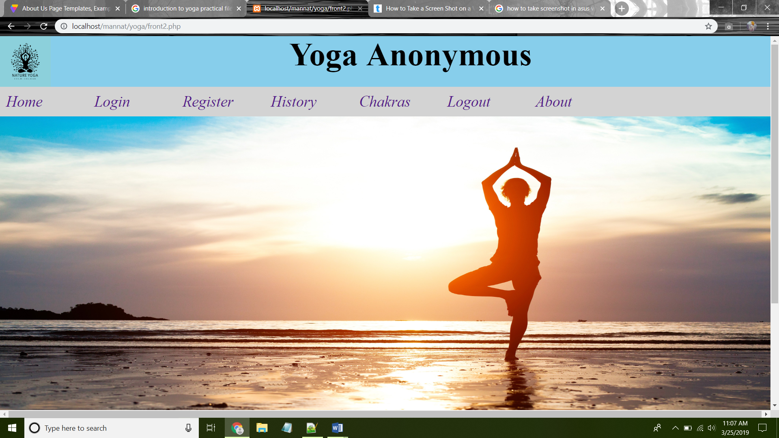

Login page output:

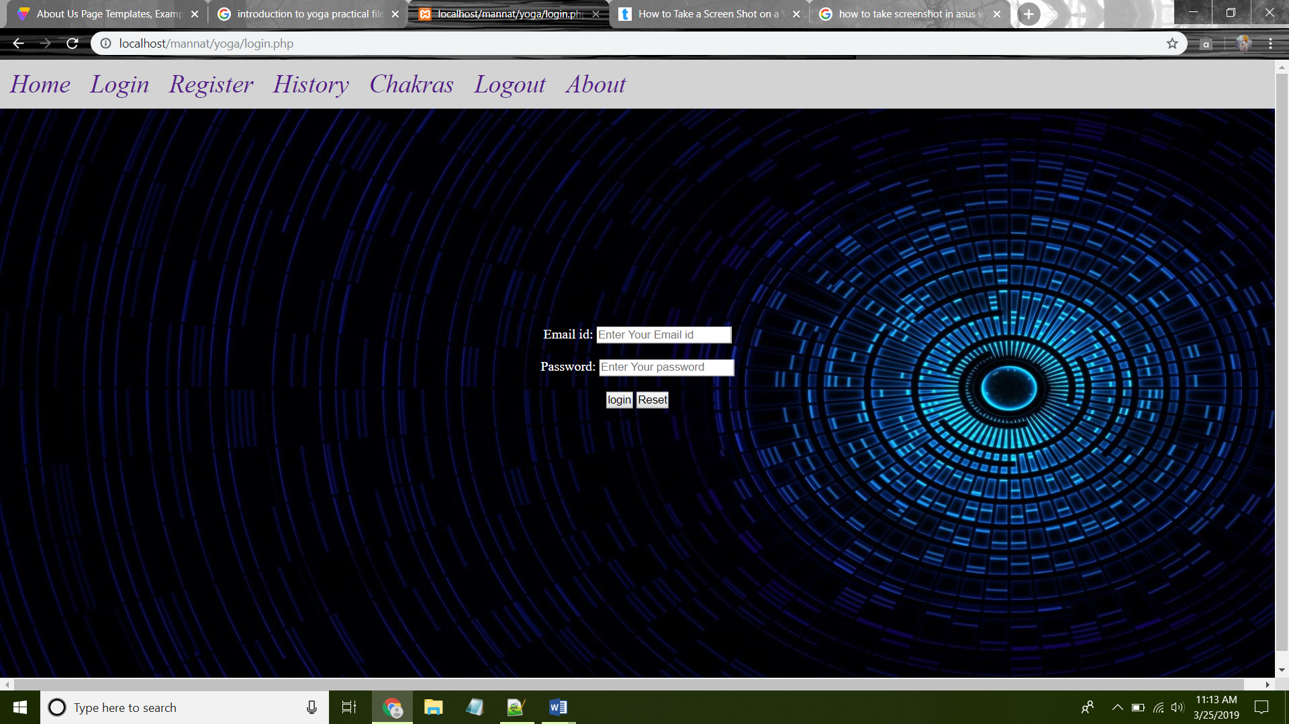

Register:-

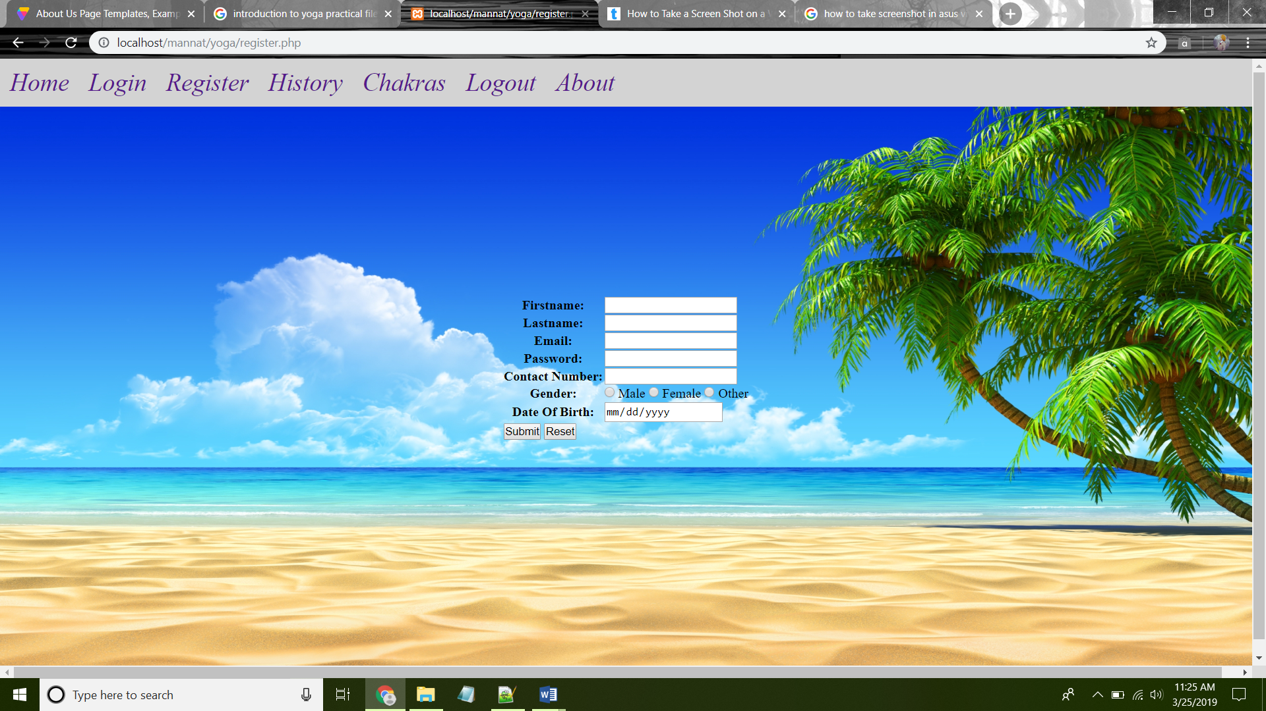

History:-

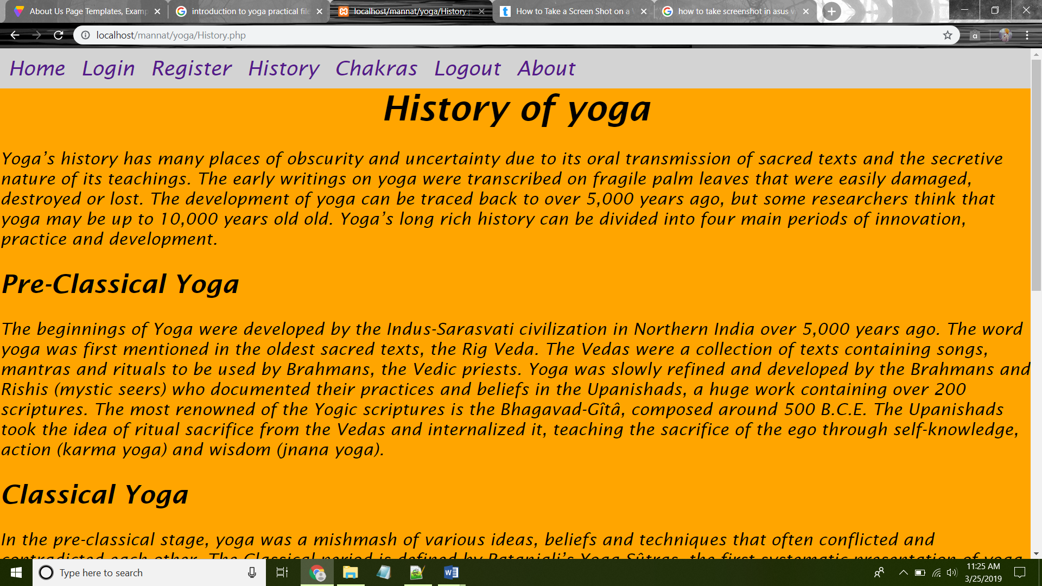

Chakras:-

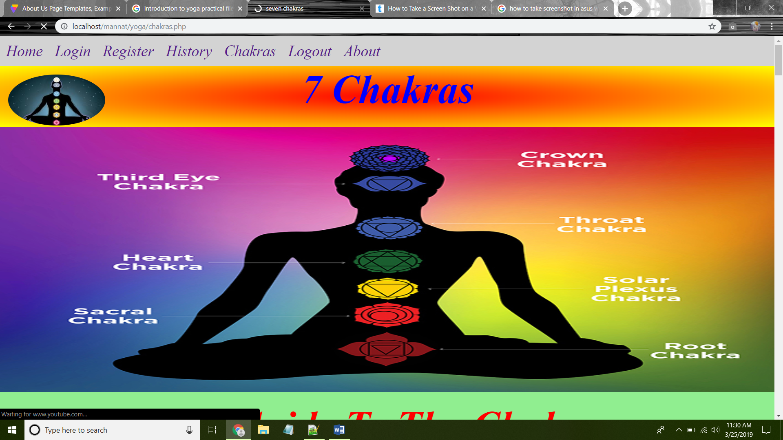

About:-

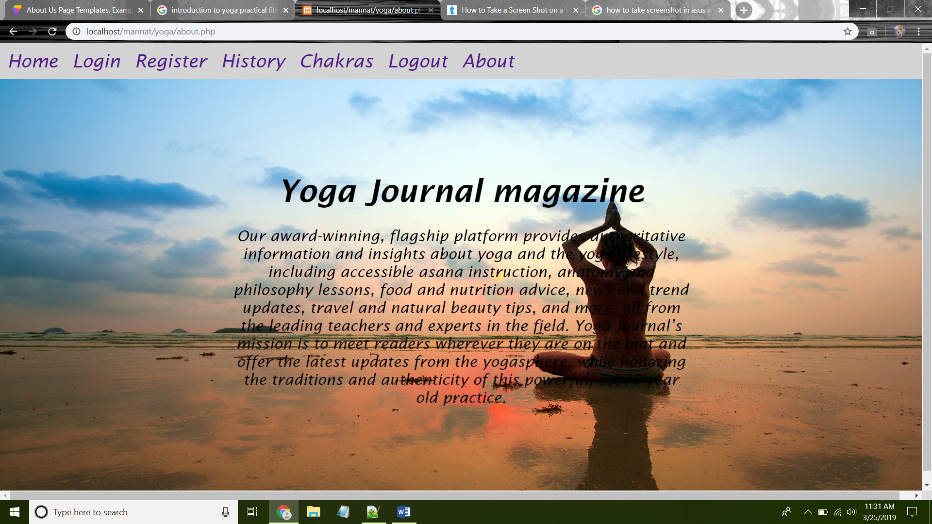

**Conclusion:-**

The package was designed in such a way that future modifications can be done easily. The following conclusions can be deduced from the development of the project.

**Yoga** is the medicine for nearly every problem. As you practice **yoga**, it does not only help you to improve your physical body but also helps in maintaining your inner peace and relaxing your mind. Thus, there is nothing that **yoga** will not help. Moreover, **yoga** is not just a one-day practice; it's a lifelong commitment.

**Future scope:-**

* In future we can add new more poses in the website.
* We are also include the information regarding the poses and video for more deeply knowledge to know how about the asan how we do the asan.
* We can all hire the masters of yoga to teach you asans by the help of video conferencing.